
Name: _____________________________
Full Test (Sections 1 and 2)

Total Time: 50 minutes

Total Marks: 45 marks

Student Result ________/ 45

MATHEMATICS METHODS Unit 1
TEST 1B -2018
Quadratics, Polynomials and Other Functions

Calculator Free Section
Time: 20 minutes
Total Marks: 18 marks

Resources allowed: SCSA Formula Sheet

Instructions to candidates
Show all your working clearly. Your working should be in sufficient detail to allow your answers to be checked readily and for marks to be awarded for reasoning. Incorrect answers given without supporting reasoning cannot be allocated any marks. For any question or part question worth more than two marks, valid working or justification is required to receive full marks. If you repeat any question, ensure that you cancel the answer you do not wish to have marked.

Question 1 | [1, 2, 3 = 6 marks]

Solve the following equations, exactly.

a) $x^{2}-64=0$

b) $x^{2}-10x=5x-26$

c) ${2x}^{2}+6x+3=0$

Question 2 | [4 marks]

The cubic equation $x^{3}-x^{2}-44x+84=0$, has $x=6$ as a solution.

Fully factorise $x^{3}-x^{2}-44x+84$ and hence determine all solutions to the equation.

Question 3 | [5 marks]

Given the quadratic function, $y=-2x^{2}+20x-42$, determine:

a) the equation for the line of symmetry.

b) the coordinates of the turning point.

c) the coordinates of the y-intercept.

d) the coordinates of the roots of the function.

Question 4 | [3 marks]

Sketch the function $y=\sqrt{-x+4}$ on the Cartesian plane below.

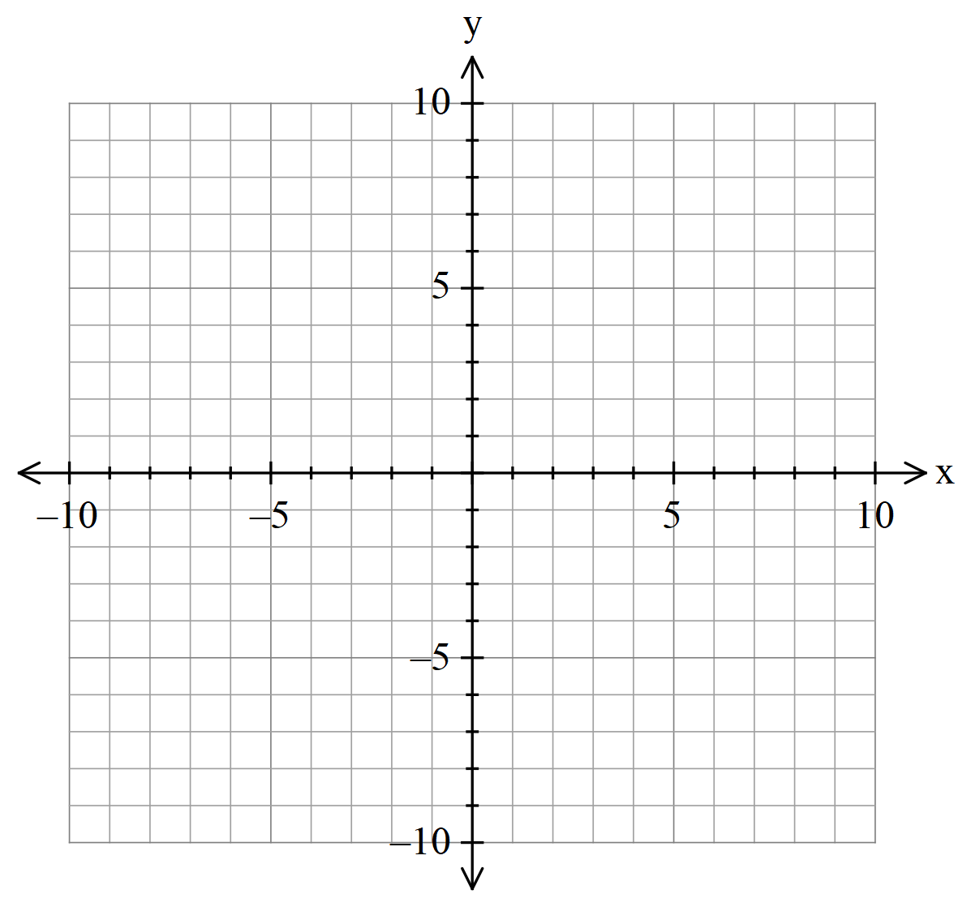


Name: _____________________________

MATHEMATICS METHODS Unit 1
TEST 1B -2018
Quadratics, Polynomials and Other Functions

Calculator Assumed Section
Time: 30 minutes
Total Marks: 27 marks

Resources allowed:
SCSA Formula Sheet
Up to three Calculators and
One A4 sheet, both sides of notes

Instructions to candidates
Show all your working clearly. Your working should be in sufficient detail to allow your answers to be checked readily and for marks to be awarded for reasoning. Incorrect answers given without supporting reasoning cannot be allocated any marks. For any question or part question worth more than two marks, valid working or justification is required to receive full marks. If you repeat any question, ensure that you cancel the answer you do not wish to have marked.

Question 5 | [6 marks]

Below are three functions, each in one of the following forms.

$f\left(x\right)={\left(ax-2\right)}^{2}$ $g\left(x\right)=\left(bx-5\right){\left(x-c\right)}^{2}$ $h\left(x\right)=\frac{d}{x-k}+m$
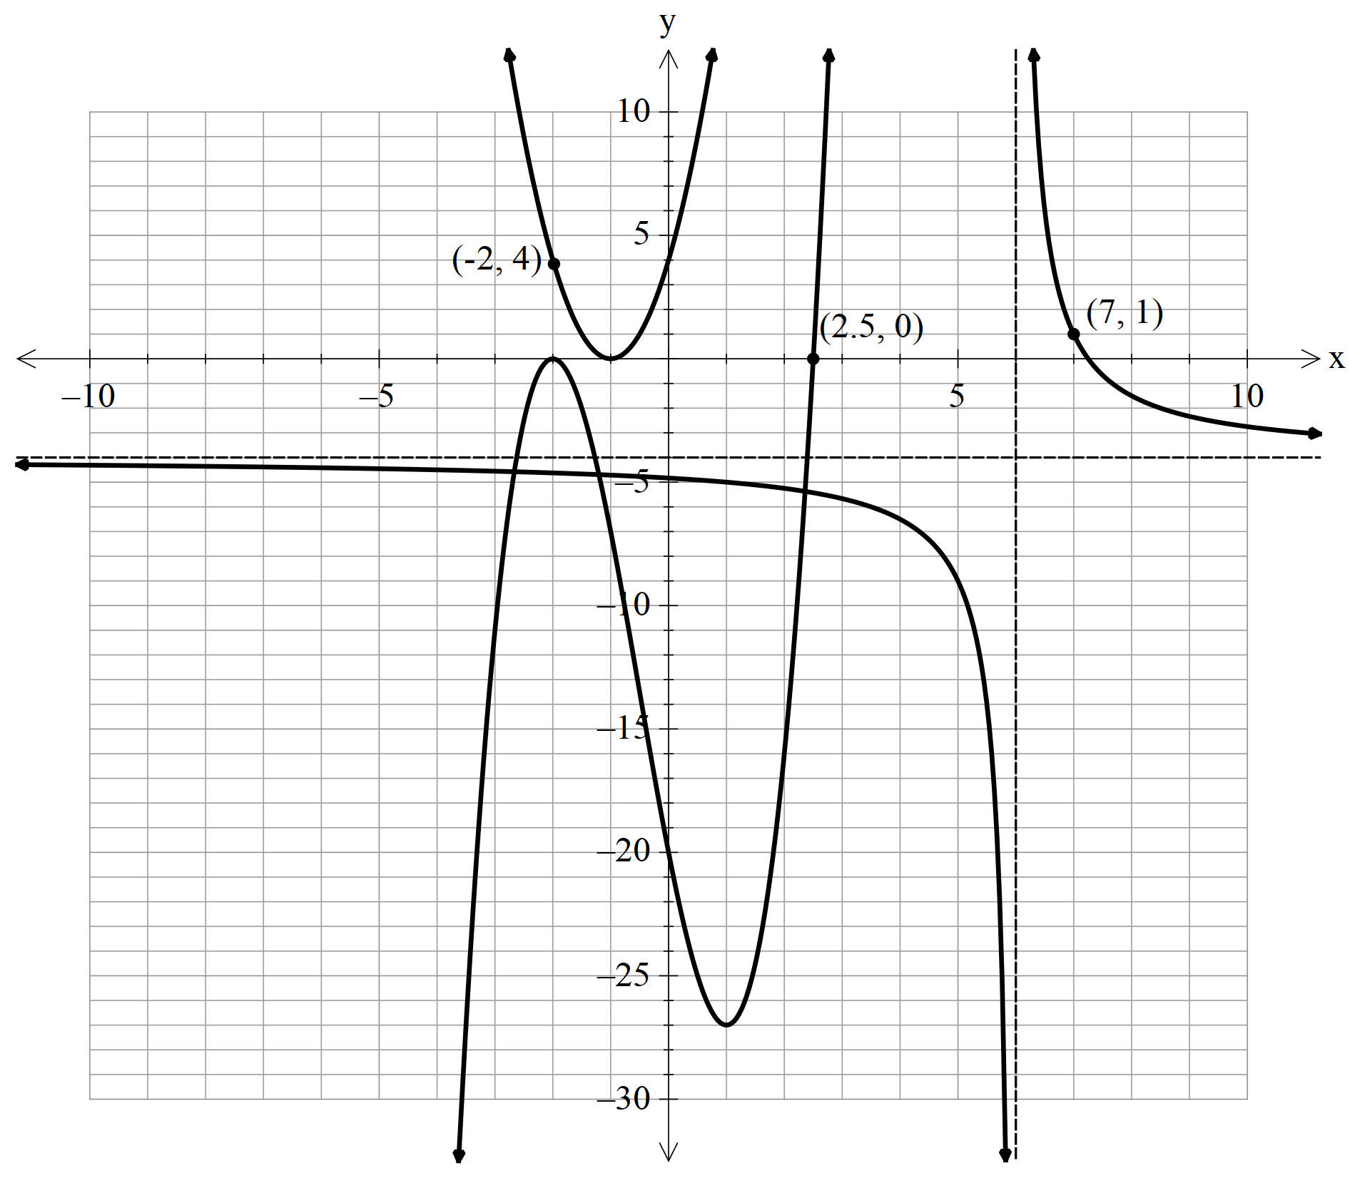

Determine the values of a, b, c, d, k and m.

Question 6 | [4 marks]

The graph of $y=f(x)$ is shown below as the solid curve.

The function under goes a number of transformations and the dashed curve, $y=g(x)$, is the result of those transformations on $y=f(x)$.
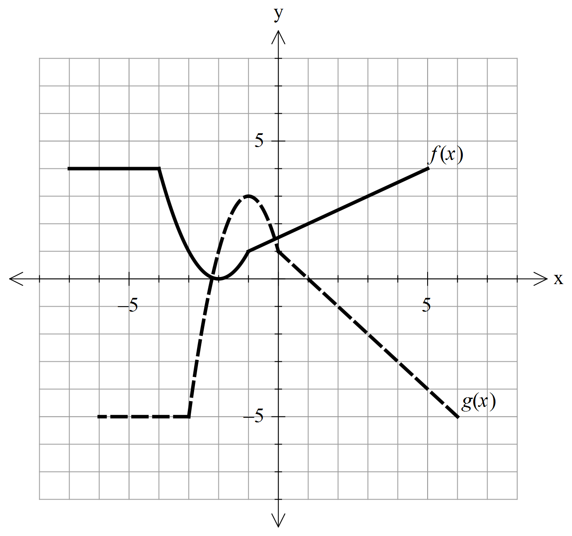

Write the function $g(x)$ in terms of $f(x)$

Question 7 | [3, 2 = 5 marks]

Determine the equation for each of the following relations.
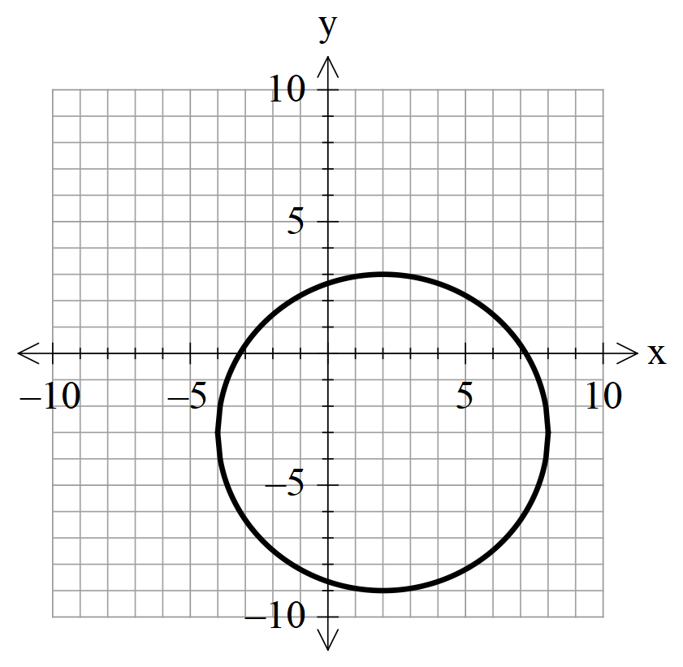
a)

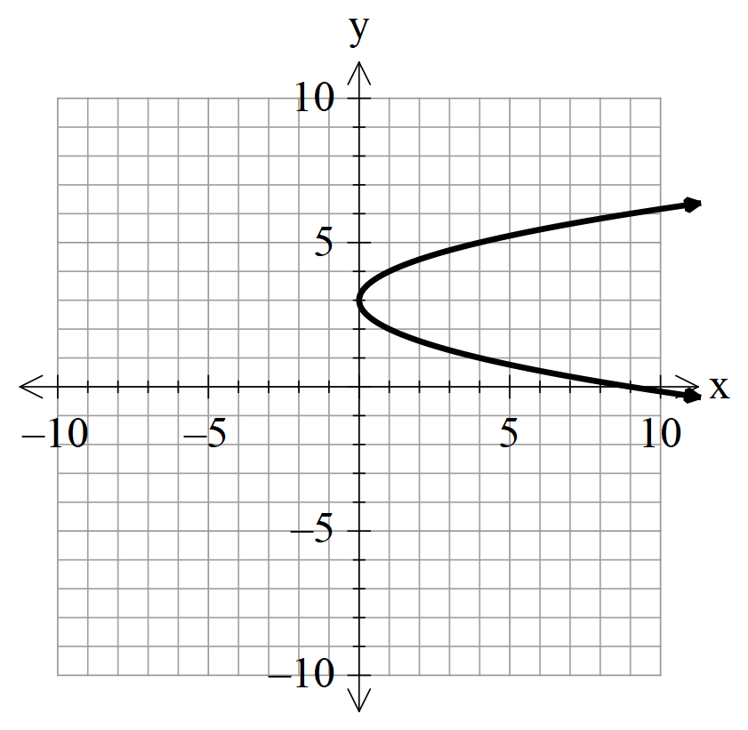
b)

Question 8 | [3 marks]

A quadratic function has a turning point at (2, 7) and passes through the point (5, 43).

Determine the equation of the function in the form $y=ax^{2}+bx+c$

Question 9 | [1, 2, 2, 2, 2 = 9 marks]

A particle P moves back and forth along a straight line. Its displacement $t$ seconds after passing a fixed
point O is given by $s=0.25t^{3}-3.25t^{2}+10t$ metres, for $0≤t≤10$ seconds.

Graph the displacement $s$ against $t$ on your graphic calculator. Use an appropriate routine to find:

a) the displacement of P when $t=10$ seconds

b) the farthest P is from O for $0≤t≤5$ seconds.

c) the farthest P is from O for $5≤t≤8$ seconds.

d) the time(s) the particle P returns to the fixed point O.

e) the total distance particle P has travelled in the first 10 seconds.

